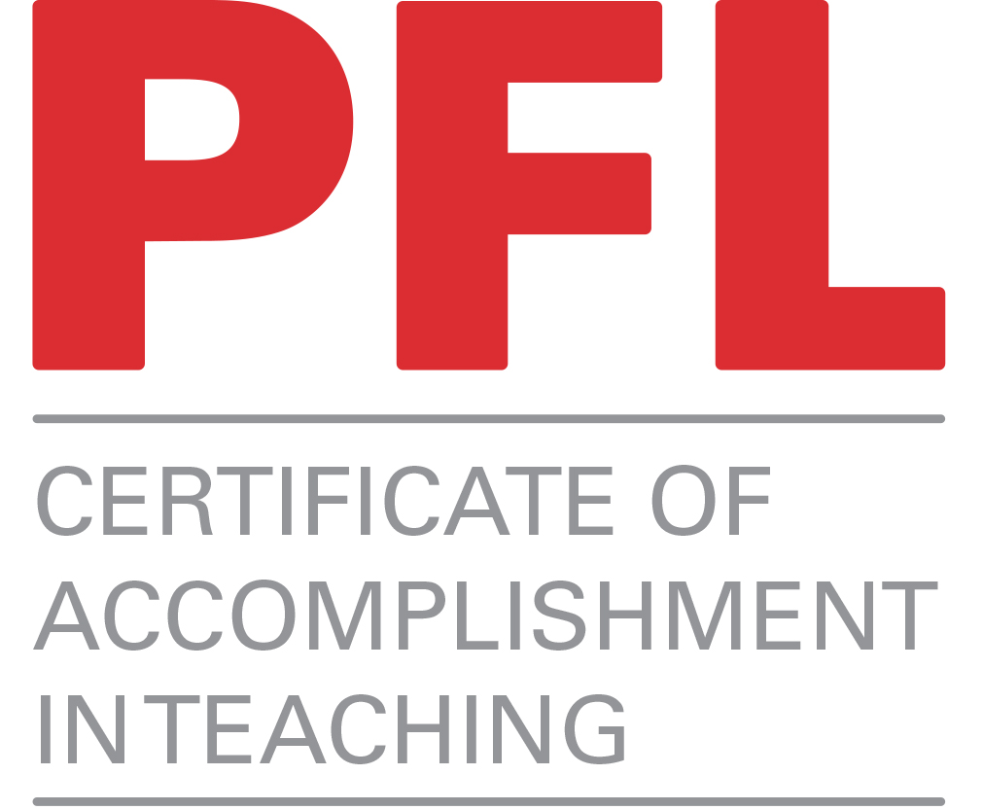
The Graduate School

Certificate of Accomplishment in Teaching Program

Classroom Observation Form – Option 2

CoAT Participant’s Name: Julia Feldman

Course observed: ADN112 3D Design
Date of observation Fall 2011
Time of class: : TTH 1:30-4:15pm
Observed by: Dana Raymond

 | Needs Improvement | Satisfactory | Well Done | Not Observed
Introduction: The lesson was introduced in an interesting and effective way, and the goal or purpose of the lesson was clear. |  |  | x
Level/Audience: The lesson was presented at an appropriate level for the intended audience. The instructor seemed to know his/her audience. |  |  | x
Content: The content was developed in an organized manner, emphasizing important points. Examples or applications helped students relate material to familiar concepts. |  |  | x
Purpose of learning activities: The learning activities had an appropriate place in the lesson, and the purpose of each activity was clear. |  |  | x
Student participation: The instructor effectively involved the students in the lesson. |  |  | x
Climate: The instructor established a positive climate of approachability, setting an appropriate tone for the instructor-student relationship. |  |  | x
Enthusiasm: The instructor showed enthusiasm for the subject and introduced interesting aspects of the content. |  |  | x
Questions: The instructor checked for student understanding and invited student questions. When questions were asked, the instructor responded clearly. |  |  | x
Visual aids: The instructor used visuals effectively. Visuals may include the board, handouts, PowerPoint presentations, content projected on a screen, etc. |  |  | x
Time management: The pace of the lesson was appropriate, and the instructor managed the time well and brought the lesson to a logical conclusion. |  |  | x

For the OBSERVER: Please answer the three discussion questions on the next page.

QUESTIONS for the OBSERVER:

- What were the strengths of this lesson?
In the context of our 3D Design (ADN112) content, Julia’s project gave breadth to the semester’s line-up of experiences. The objective in any design experience is to make available a range of possible solutions, including concept, form, materials, processes, and imagination. Any preconceived limitations typically require breaking down and then expanding in order for students to search beyond the obvious or narrow scope of initial ideas.
Julia brought to the class her expertise in fibers/fashion that I do not possess. This obviously enriched the experience, not only for the students, but also for myself. She also directly built on my belief that even when one struggles with creativity, there is always room for constructive fun in learning experiences.

- What suggestions do you recommend for this instructor?
The best advice I could give Julia is to continue offering open-ended pursuits while retaining the capacity to recognize and respond to each student as an individual with unique experiences and visions.

- Are there any additional comments you would like to share with the instructor?
It was a treat for me to teach with Julia. The students hopefully recognized the potential for their growth coming from two different perspectives. When two teachers collaborate, it is a win-win situation for all involved. Nobody leaves a class like that without rewarding accomplishments.

REFLECTION QUESTIONS for the CoAT PARTICIPANT

Complete this section after your class has been observed. Attach your comments to this form and submit online. If possible, it is best to meet with your observer to discuss this observation experience before completing the questions.

Project: Costume design reflecting a future or past part of your life. Be prepared to discuss and answer question on the reason you designed and created this persona.

1. What did you feel went well in this class session?

I timed the project to be completed prior to Art + Design’s yearly Halloween Bash. Not only were the students excited about creating something most had never attempted, they were determined to complete the project in a timely manner. On this particular day we were sketching ideas and discussing materials.

2. What would you like to change about this class session if you had to teach it again?

I would add a writing component before starting the project. Having to commit to paper their reasons for designs the costumes would have added authenticity to the project.

3. In the light of the observer’s comments, what aspects of your teaching approach will you look
at changing in the future? How will you do this?

In discussing the project with Professor Raymond, I should have broken the class of approximately thirty-five students into smaller groups based on the techniques they were using. It would have been easier on me. The students were so excited and the majority had no background. I taught too many techniques one on one, such as how to use a sewing machine, which would have been better use of my time (and the many hours of time outside of class) if I had taught group lessons.

4. What have you found useful/not so useful about the observation process?

I had been previously observed when I taught elementary school and K-12 art. It is always useful to have feedback from an experienced professor – there are so many little things you only learn with time and experience. Having Dana Raymond as an open and positive mentor was a positive experience as he filled me in on some of his little “tricks of the trade”. In addition he always had suggestions for my personal artistic growth and directed me towards interested artists and materials for further research.

Form adapted with permission from: Pinder, T. and Ross, C. (2007). Strategies for Teaching Assistant and International Teaching Assistant Development. Jossey-Bass.

